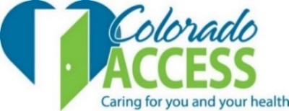

HEALTH FIRST COLORADO

REGION 5 PROGRAM IMPROVEMENT ADVISORY COMMITTEE
(City and County of Denver)
September 16, 2019, 4:00-6:00pm

Location: St Joseph’s Hospital Campus, Russell Pavilion
1375 E 19th Ave, Denver CO 80218

AGENDA
 |  | Participation Spectrum
4:00 | Dinner, Welcome and Introductions – Judy Shlay, Chair | Collaborate
4:15 | Approval of June meeting minutes – Judy Shlay, Chair | Collaborate
4:15 | Quick Training on Working Together Effectively – Kelly Marshall, COA Community Engagement  - Participation Spectrum  - Fist-to-Five | Inform
4:20 | Regional Pay for Performance Measure – Potentially Avoidable Conditions/Costs (PAC)  Presentation and Discussion – Sarah Lambie, COA Quality Team | Consult
5:00 | Policy changes from the state – a shift in priorities towards cost containment, avoidance and reduction  Ben Harris, CO Department of Health Care Policy & Financing (HCPF); Kelly Marshall | Inform/ Consult
5:40 | General Updates and Emerging Issues – Judy Shlay  This is an opportunity for Committee members to 1) share relevant updates, 2) raise relevant issues or trends in the region; and 2) put forth potential future agenda items. | Collaborate
5:50 | Public Comment – Judy Shlay
6:00 | Meeting Adjourned
PARTICIPATION SPECTRUM:
INFORM: COA provides the Council with balanced and objective information (FYI only).
CONSULT: COA obtains Council feedback on analysis, alternatives, and/or decisions to ensure concerns are understood and considered (Council is advisory, COA makes final decision).
COLLABORATE: COA partners with the Council in each aspect of the decision including alternatives and solutions – Collective Impact (COA and the Council design and decide together).

